Project Design Phase-II
Technology Stack (Architecture & Stack)

Date | [DD Month YYYY]
Team ID | [Team ID]
Project Name | Automated Network Request Management in ServiceNow
Maximum Marks | 4 Marks

Technical Architecture:
The Deliverable shall include the architectural diagram as below and the information as per the table1 & table 2
Technical Architecture — Automated Network Request Management in ServiceNow
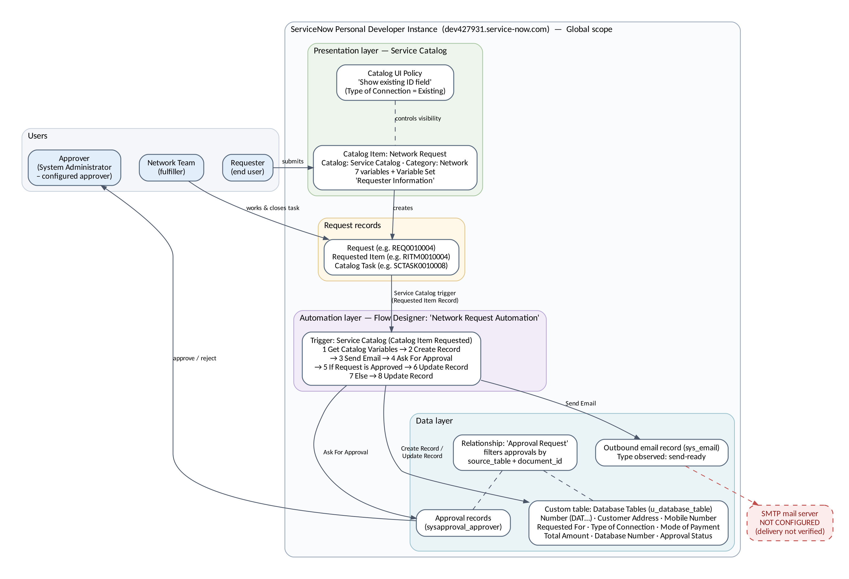
Figure 1: Technical architecture (all components run on the ServiceNow developer instance)

Table-1 : Components & Technologies:
S.No | Component | Description | Technology
 | User Interface | Requesters use the Network Request catalog item form in the Service Catalog. Approvers and the Network Team use the ServiceNow platform UI (approval record, catalog task, Database Tables list). | ServiceNow Service Catalog (catalog item, 7 variables, variable set 'Requester Information')
 | Application Logic-1 | Dynamic form behaviour: shows 'Enter your existing id' only when Type of Connection = Existing. | Catalog UI Policy 'Show existing ID field'
 | Application Logic-2 | Workflow automation: Service Catalog trigger (Catalog Item Requested) → Get Catalog Variables → Create Database Tables Record → Send Email → Ask For Approval → If Request is Approved → Update Record (then / Else). | ServiceNow Flow Designer — flow 'Network Request Automation' (Global scope)
 | Application Logic-3 | Approval and related-list filtering: approval requested from System Administrator; the 'Approval Request' relationship filters approvals by source_table and document_id. | Flow Designer Ask For Approval; relationship script (server-side JavaScript, GlideRecord query)
 | Database | Custom table Database Tables (u_database_table): Number, Database Number, Customer Address, Mobile Number, Requested For, Type of Connection, Mode of Payment, Total Amount, Approval Status (String) and Assignment to (reference to User), plus standard request, task, approval and email tables. | ServiceNow platform database (custom table + sc_request / sc_req_item / sc_task / sysapproval_approver / sys_email)
 | Cloud Database | All data is stored in the ServiceNow-hosted instance; no separate cloud database is used. | ServiceNow-hosted instance (Personal Developer Instance)
 | File Storage | No file-storage requirement in the implemented scope. | Not used
 | External API-1 | Outbound email delivery requires an SMTP mail server. The email record is generated, but no active SMTP account is configured, so delivery is not verified. | ServiceNow email (SMTP) — not configured
 | External API-2 | No external APIs are integrated. | Not used
 | Machine Learning Model | No machine-learning model is used. | Not used
 | Infrastructure (Server / Cloud) | Hosted by ServiceNow; no local server. Instance: https://dev427931.service-now.com. The ServiceNow release is not recorded in the available evidence. | ServiceNow cloud (Personal Developer Instance)

Table-2: Application Characteristics:
S.No | Characteristics | Description | Technology
 | Open-Source Frameworks | Not applicable — the solution is built with proprietary ServiceNow platform features. No open-source framework is used. | N/A
 | Security Implementations | ServiceNow user authentication and role-based access; approval limited to the configured approver. No ACLs are listed for u_database_table (BG-04) — to be defined and tested. No credentials in the documentation. | ServiceNow roles / ACLs, approval engine
 | Scalable Architecture | Configuration-based layers (catalog → flow → table/approvals) on a multi-tenant cloud platform. New catalog items, approvers or flow branches can be added without architectural change. | ServiceNow Now Platform, Flow Designer
 | Availability | Availability is provided by ServiceNow hosting. Developer instances may hibernate when idle, so this build is suitable for development and demonstration only. | ServiceNow-hosted PDI
 | Performance | Flows run in the background by default. In one test run the automated steps took 98–925 ms each (Get Catalog Variables 98 ms, Create Record 152 ms, Send Email 925 ms). No load testing yet. | Flow Designer asynchronous execution

References:
https://c4model.com/
https://developer.ibm.com/patterns/online-order-processing-system-during-pandemic/
https://www.ibm.com/cloud/architecture
https://aws.amazon.com/architecture
https://medium.com/the-internal-startup/how-to-draw-useful-technical-architecture-diagrams-2d20c9fda90d

